* **MODUL 10**

1. Download data penyakit Immunotherapy dari https://archive.ics.uci.edu/ml/machine-learning-databases/00428/ atau download dari classroom dengan nama file Immunotherapy.csv Lakukan tahapan-tahapan dalam menentukan klasifikasi untuk memprediksi dengan algoritma Naïve Bayes Classifier.

* **Kode**

import pandas as pd

import numpy as np

dataimmun = pd.read_excel("Documents/Tugas Kuliah/5P42/Data Science/Praktek/Immunotherapy.xlsx")

dataimmun.info()

dataimmun.empty

x = dataimmun.drop(["Result_of_Treatment"], axis = 1)

x.head()

y = dataimmun["Result_of_Treatment"]

y.head()

from sklearn.model_selection import train_test_split

x_train, x_test, y_train, y_test = train_test_split(x, y, test_size = 0.2, random_state = 123)

from sklearn.naive_bayes import GaussianNB

modelnb = GaussianNB()

nbtrain = modelnb.fit(x_train, y_train)

nbtrain.class_count_

y_pred = nbtrain.predict(x_test)

y_pred

nbtrain.predict_proba(x_test)

from sklearn.metrics import confusion_matrix

confusion_matrix(y_test, y_pred)

from sklearn.metrics import classification_report

print(classification_report(y_test,y_pred))

* **Hasil**

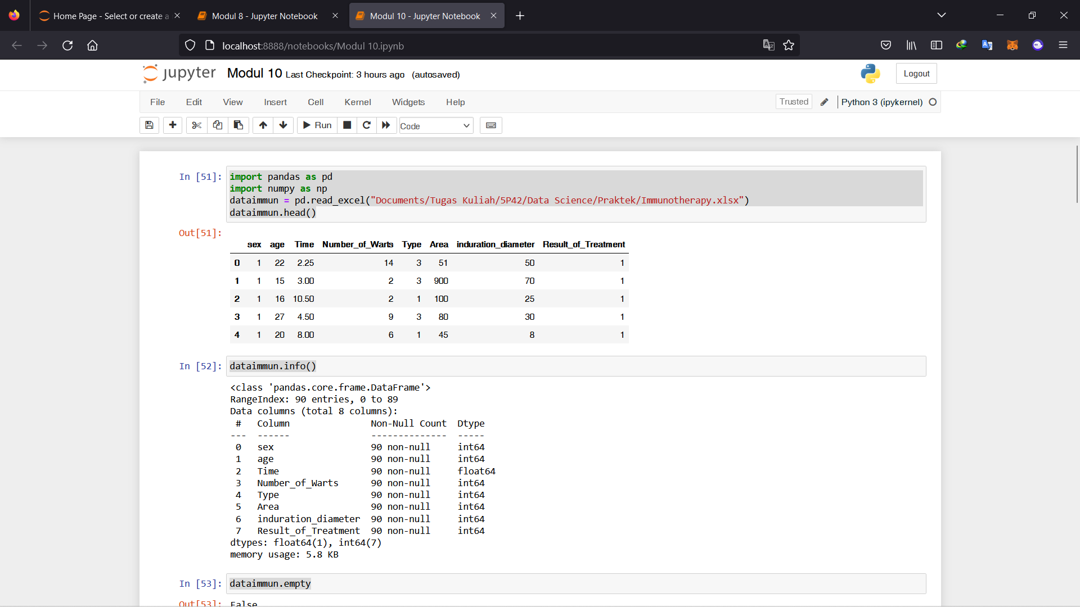

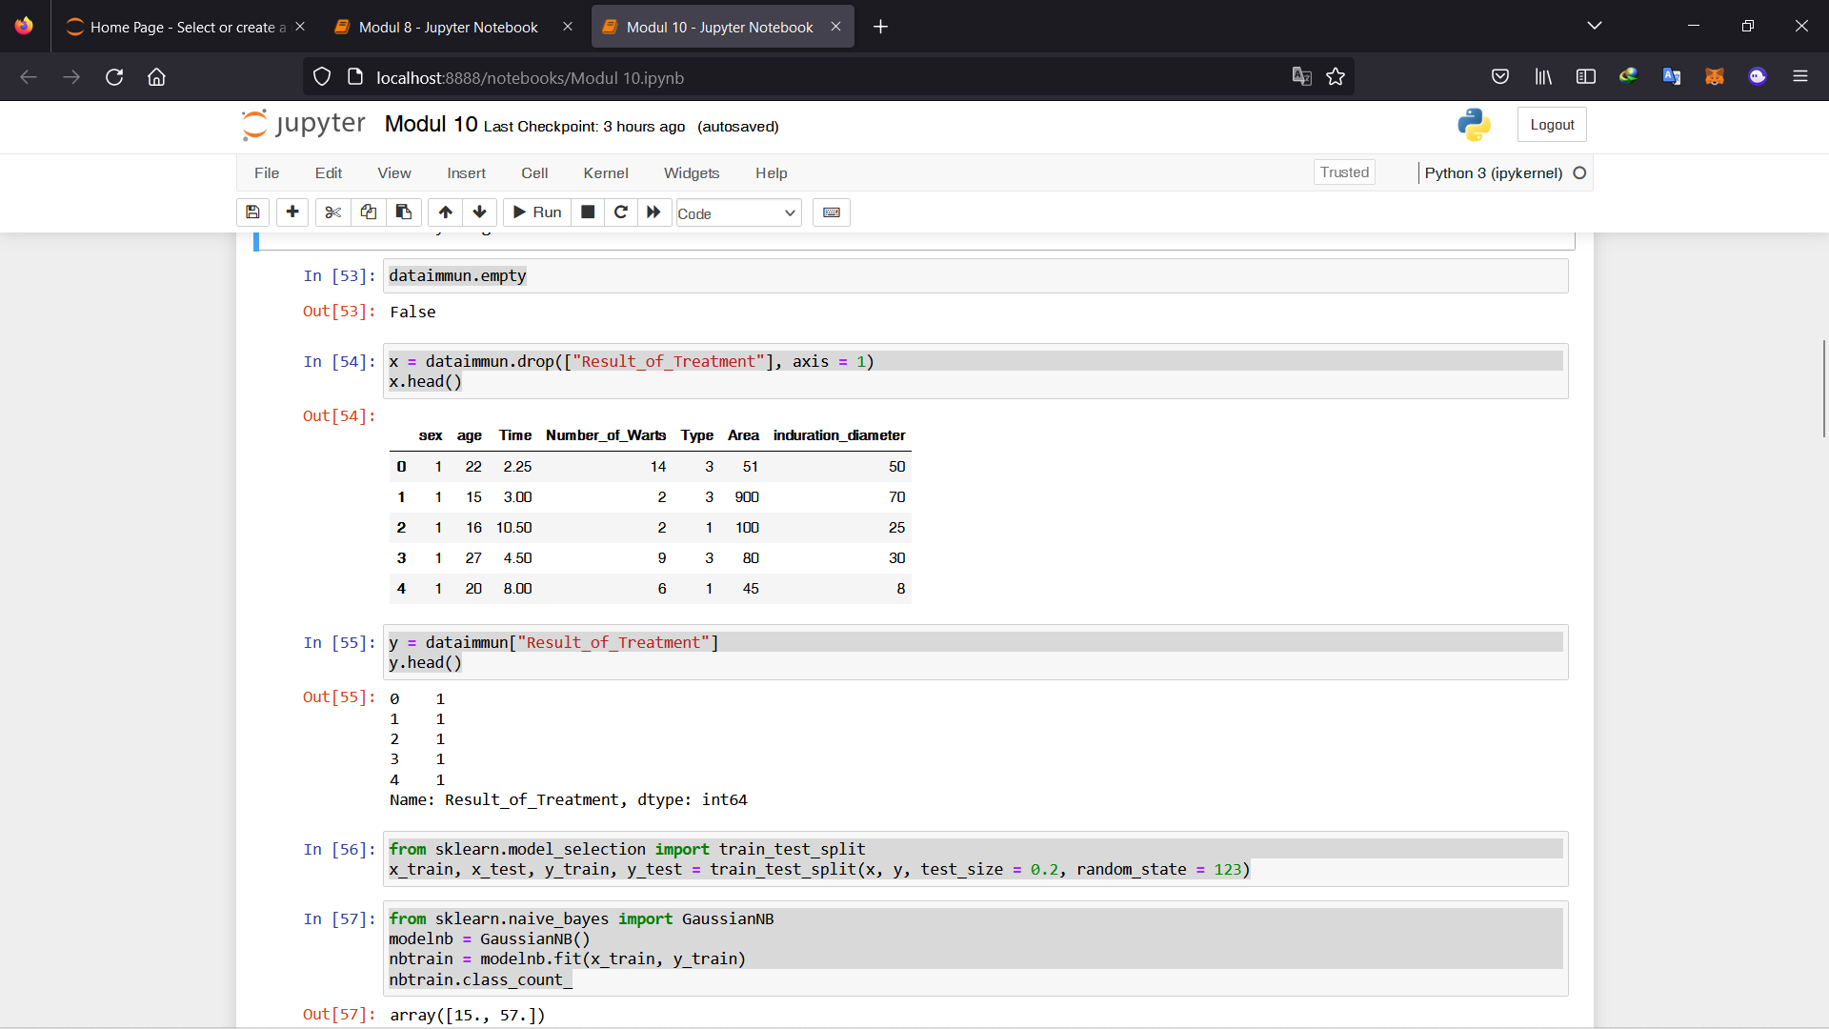

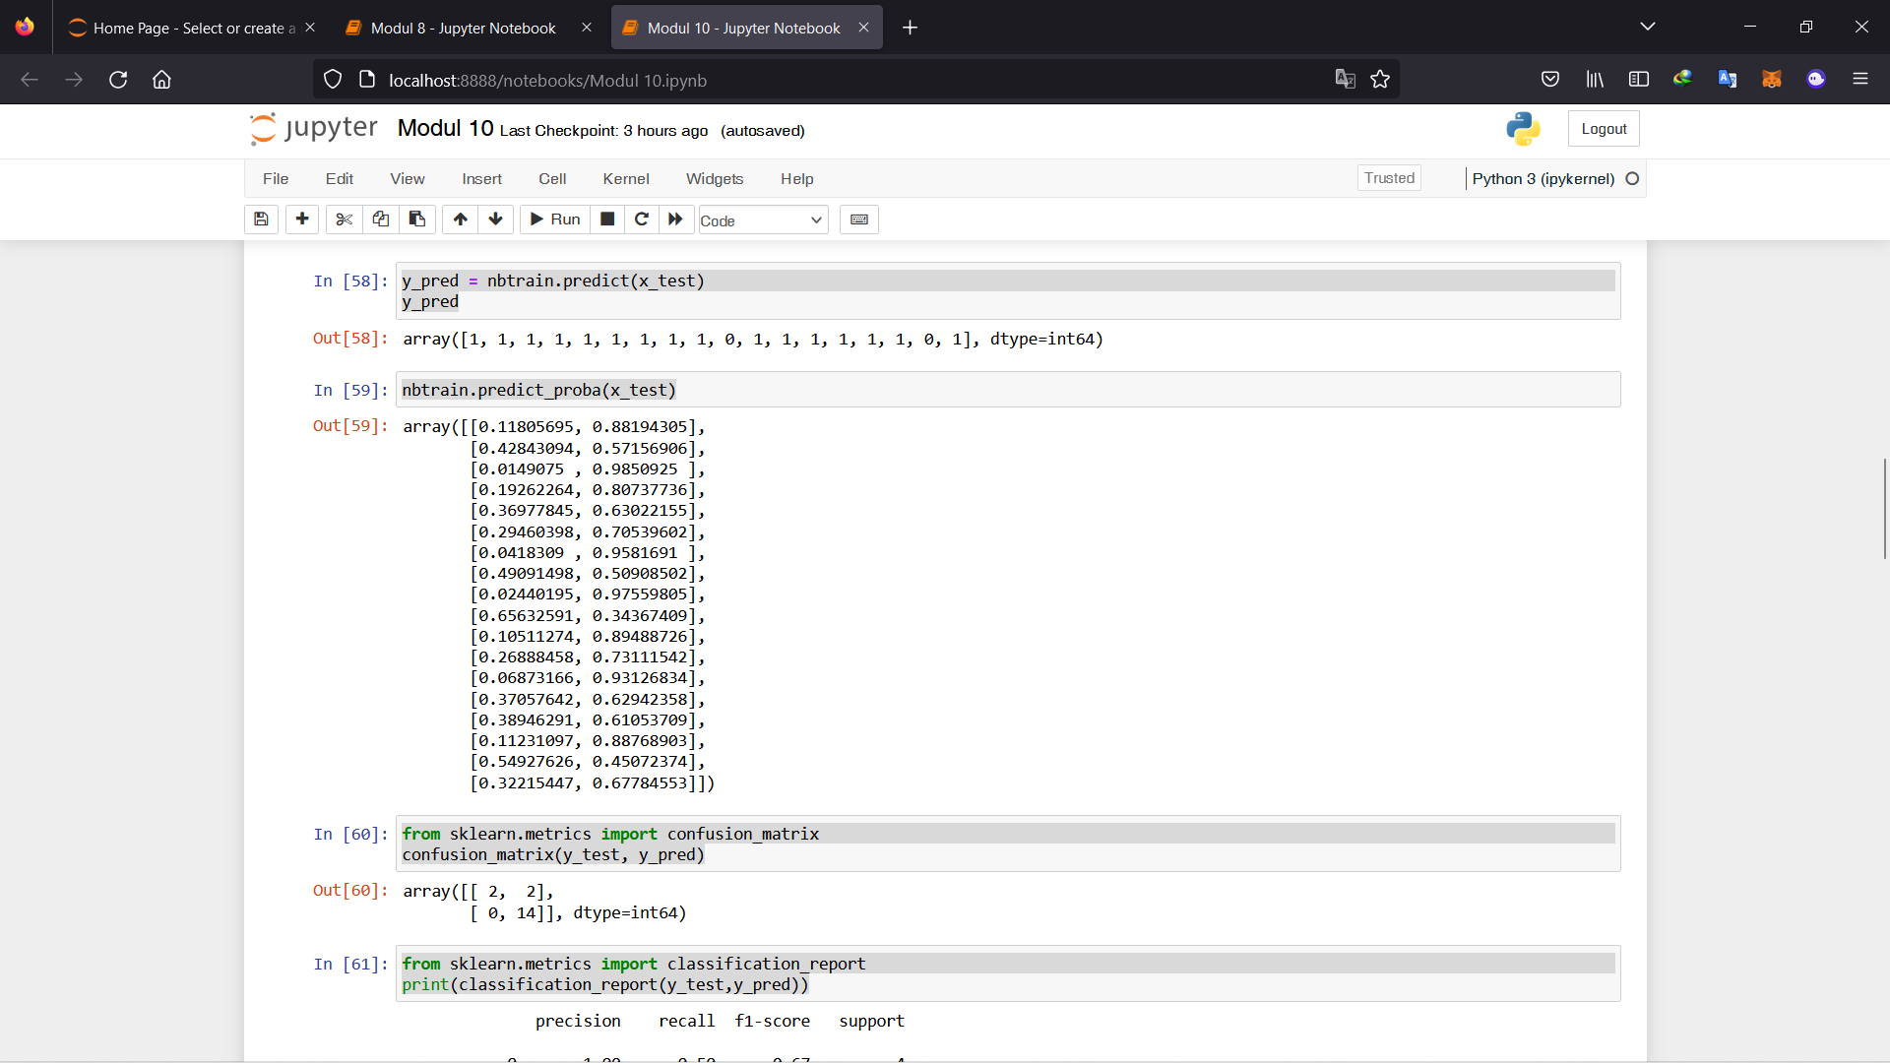

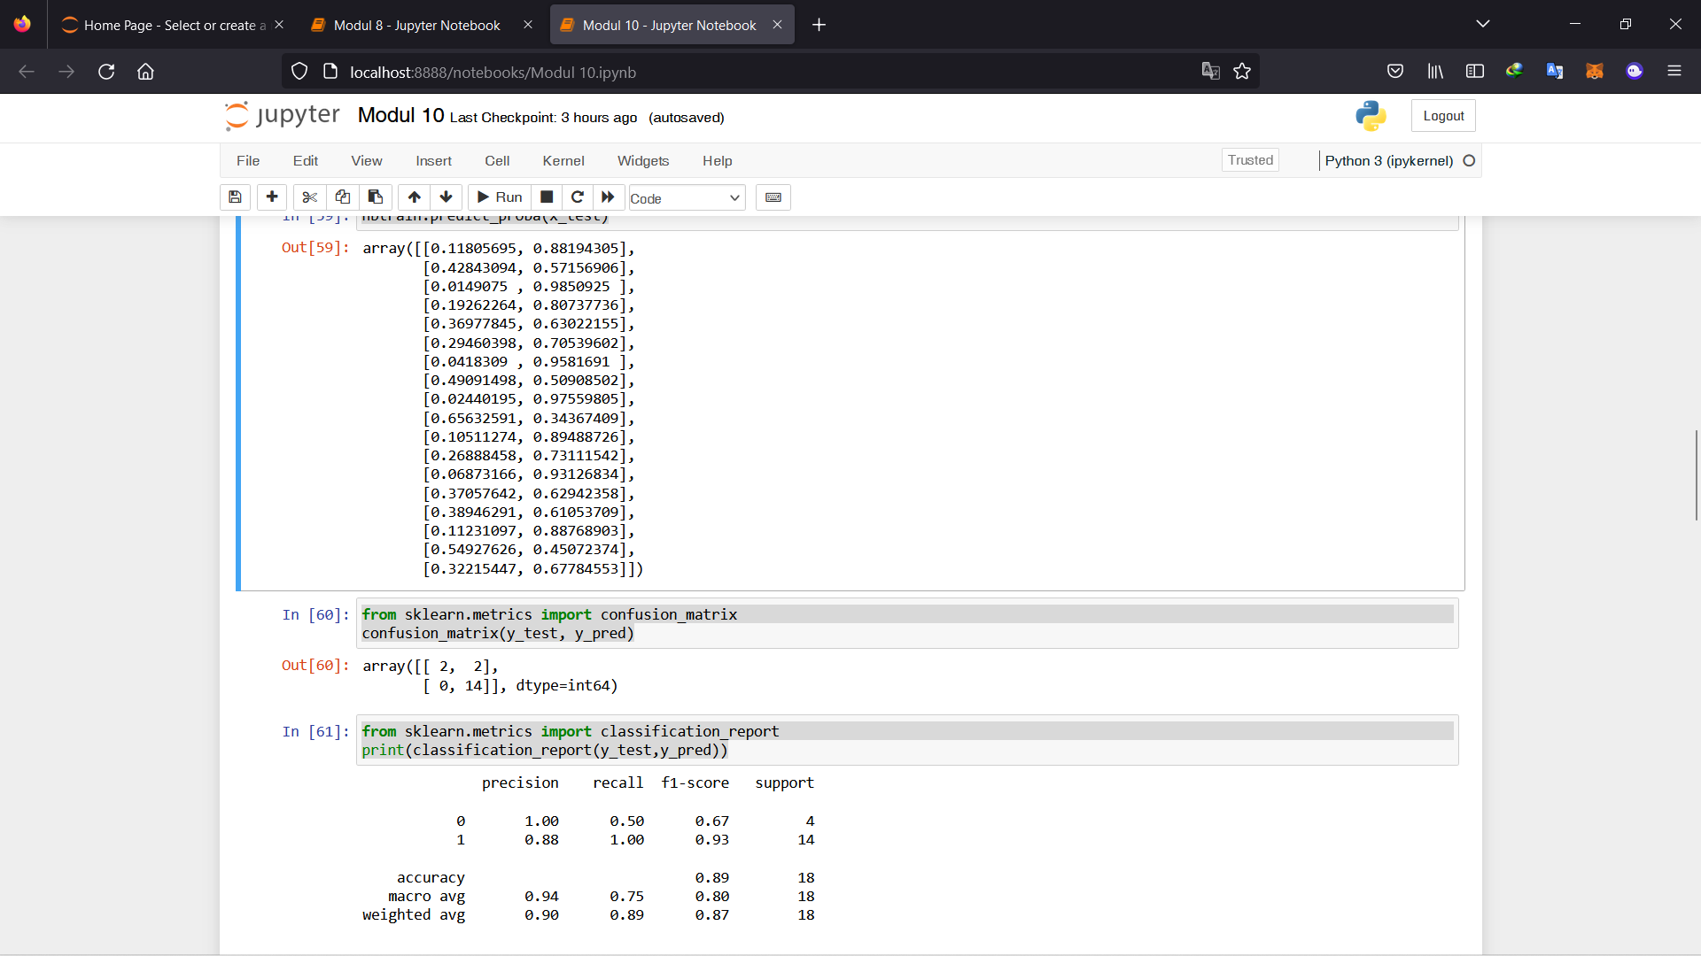

1. Lakukan analisis dengan menggunakan naïve bayes classifier data mengenai play tenis berikut :

* **Kode**

import pandas as pd

import numpy as np

import random

import math

import json

import re

from random import randrange

from random import seed

import csv

import matplotlib.pyplot as plt

datatenis = pd.read_csv("Documents/Tugas Kuliah/5P42/Data Science/Praktek/play_tenis.csv")

datatenis

datatenis.info()

datatenis['Outlook'] = datatenis['Outlook'].apply({'Sunny':0, 'Cloudy':1, 'Rainy':2}.get)

datatenis['Temperature'] = datatenis['Temperature'].apply({'Hot':0, 'Mild':1, 'Cool':2}.get)

datatenis['Humidity'] = datatenis['Humidity'].apply({'High':0, 'Normal':1}.get)

datatenis

X = datatenis.drop(["Play"], axis=1)

X.head(11)

Y = datatenis["Play"]

Y.head(11)

from sklearn.model_selection import train_test_split

from sklearn.naive_bayes import GaussianNB

modelnb = GaussianNB()

nbtrain = modelnb.fit(X, Y)

dataTestTenis = pd.read_csv("Documents/Tugas Kuliah/5P42/Data Science/Praktek/dataTest_tenis.csv")

dataTestTenis

dataTestTenis['Outlook'] = dataTestTenis['Outlook'].apply({'Sunny':0, 'Cloudy':1, 'Rainy':2}.get)

dataTestTenis['Temperature'] = dataTestTenis['Temperature'].apply({'Hot':0, 'Mild':1, 'Cool':2}.get)

dataTestTenis['Humidity'] = dataTestTenis['Humidity'].apply({'High':0, 'Normal':1}.get)

dataTestTenis

X = dataTestTenis.drop(["Play"], axis=1)

X.head(11)

Y = dataTestTenis["Play"]

Y.head(11)

Y_predict = nbtrain.predict(X)

print("Prediksi Naive Bayes Mengenai Data Play Tenis Adalah : ", Y_predict)

* **Hasil**

